Blinkit Grocery Analysis
- See all the data imported:
SELECT * FROM blinkit_data
- DATA CLEANING:
- Standardizing the Item_Fat_Content field ensures consistent, accurate analysis. Variations like "LF", "low fat", and "Low Fat" can break filtering, grouping, and reporting. Cleaning these entries improves data quality and makes the dataset more reliable for insights and decision-making.
UPDATE blinkit_data
SET Item_Fat_Content =
CASE
WHEN Item_Fat_Content IN ('LF','low fat') THEN 'Low Fat'
WHEN Item_Fat_Content = 'reg' THEN 'Regular'
ELSE Item_Fat_Content
END;
After executing this query check the data has been cleaned or not using below query
SELECT DISTINCT (Item_Fat_Content) FROM blinkit_data;

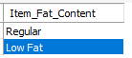

A. KPI’s
1. TOTAL SALES:
SELECT CAST(SUM(Total_sales)/1000000 AS DECIMAL(10,2)) AS Total_Sales_Millions
FROM blinkit_data;
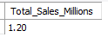
2. AVERAGE SALES
SELECT CAST(AVG(Total_Sales) AS DECIMAL (10,0)) AS Avg_Sales
FROM blinkit_data;
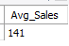
3. NO OF ITEMS
SELECT COUNT(*) AS No_of_Items
FROM blinkit_data;
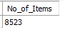
4. AVG RATING
SELECT CAST(AVG(Rating) AS DECIMAL(10,1)) AS Avg_Rating
FROM blinkit_data;
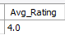

B. Total Sales by Fat Content:
SELECT Item_Fat_Content,
CAST(SUM(Total_Sales) AS DECIMAL (10,2)) AS Total_Sales,
CAST(SUM(Total_Sales) AS DECIMAL (10,1)) AS Avg_Sales,
COUNT(*) AS No_Of_Items,
CAST(AVG(rating) AS DECIMAL (10,2)) AS Avg_Rating
FROM blinkit_data
GROUP BY Item_Fat_Content
ORDER BY Total_Sales DESC;

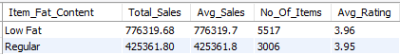

C. Total Sales by Item Type
SELECT Item_Type,
CAST(SUM(Total_Sales) AS DECIMAL (10,2)) AS Total_Sales,
CAST(SUM(Total_Sales) AS DECIMAL (10,1)) AS Avg_Sales,
COUNT(*) AS No_Of_Items,
CAST(AVG(rating) AS DECIMAL (10,2)) AS Avg_Rating
FROM blinkit_data
GROUP BY Item_Type
ORDER BY Total_Sales DESC;

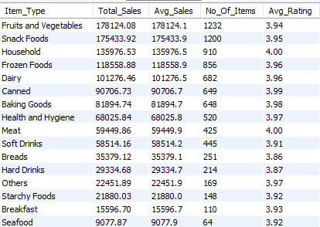

D. Fat Content by Outlet for Total Sales
SELECT Outlet_Location_Type,
ROUND(SUM(CASE WHEN Item_Fat_Content = 'Low Fat' THEN Total_Sales ELSE 0 END), 2) AS Low_Fat,
ROUND(SUM(CASE WHEN Item_Fat_Content = 'Regular' THEN Total_Sales ELSE 0 END), 2) AS Regular
FROM blinkit_data
GROUP BY Outlet_Location_Type
ORDER BY Outlet_Location_Type;

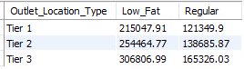

E. Total Sales by Outlet Establishment
SELECT Outlet_Establishment_Year,
CAST(SUM(Total_Sales) AS DECIMAL(10,2)) AS Total_Sales,
CAST(AVG(Total_Sales) AS DECIMAL(10,1)) AS Avg_Sales,
COUNT(*) AS No_of_Items,
CAST(AVG(Rating) AS DECIMAL(10,2)) AS Avg_Rating
FROM blinkit_data
GROUP BY Outlet_Establishment_Year
ORDER BY Total_Sales DESC;

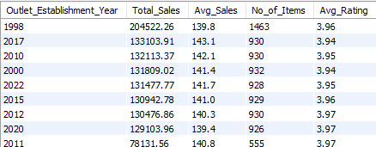

F. Percentage of Sales by Outlet Size
SELECT Outlet_Size,
CAST(SUM(Total_Sales) AS DECIMAL(10,2)) AS Total_Sales,
CAST((SUM(Total_Sales) * 100.0 / SUM(SUM(Total_Sales)) OVER()) AS DECIMAL (10,2)) AS Sales_Percentage
FROM blinkit_data
GROUP BY Outlet_Size
ORDER BY Total_Sales DESC;

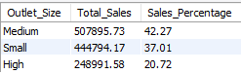

G. Sales by Outlet Location
SELECT Outlet_Location_Type,
CAST(SUM(Total_Sales) AS DECIMAL(10,2)) AS Total_Sales,
CAST((SUM(Total_Sales) * 100.0 / SUM(SUM(Total_Sales)) OVER()) AS DECIMAL (10,2)) AS Sales_Percentage,
CAST(AVG(Total_Sales) AS DECIMAL(10,1)) AS Avg_Sales,
COUNT(*) AS No_of_Items,
CAST(AVG(Rating) AS DECIMAL(10,2)) Avg_Rating
FROM blinkit_data
GROUP BY Outlet_Location_Type
ORDER BY Total_Sales DESC;

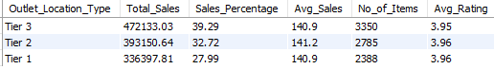

H. All Metrics by Outlet Type:
SELECT Outlet_Type,
CAST(SUM(Total_Sales) AS DECIMAL(10,2)) AS Total_Sales,
CAST((SUM(Total_Sales) * 100.0 / SUM(SUM(Total_Sales)) OVER()) AS DECIMAL (10,2)) AS Sales_Percentage,
CAST(AVG(Total_Sales) AS DECIMAL(10,1)) AS Avg_Sales,
COUNT(*) AS No_of_Items,
CAST(AVG(Rating) AS DECIMAL(10,2)) Avg_Rating
FROM blinkit_data
GROUP BY Outlet_Type
ORDER BY Total_Sales DESC;

